

**CSE302: Database Systems (Section 7)**

**Spring 2024**

**Project Report**

Inventory Management System with POS

<https://shorturl.at/phyNa>

**Submitted by:**

|  |  |  |
| --- | --- | --- |
| **Student ID** | **Student Name** | **Contribution Percentage** |
| 2022-3-60-141 | Saleh Rafi | 25% |
| 2022-3-60-109 | Sheikh Sarafat Hossain | 25% |
| 2022-3-60-192 | Rijia Parveen Raya | 25% |
| 2022-3-60-243 | Wasimul Bari Rahat | 25% |

# E-R Model of the Project

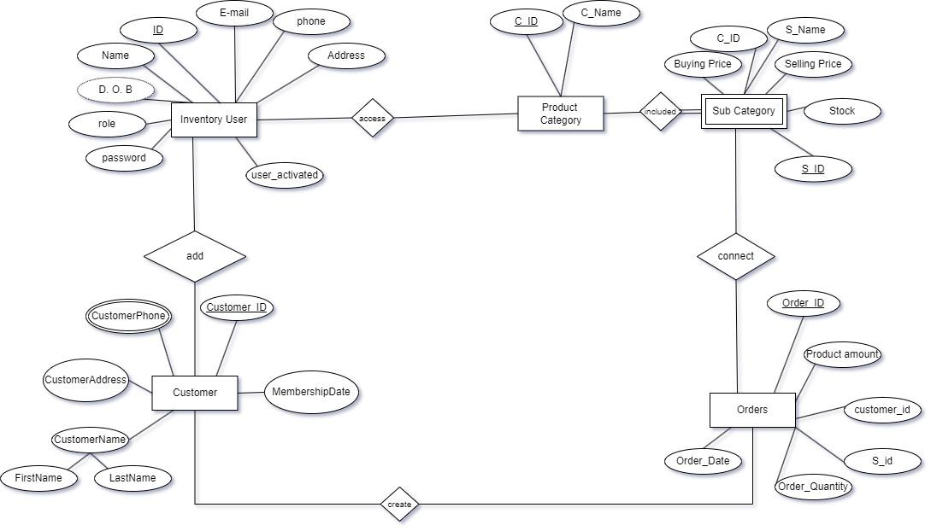

# Schema Design of the Project

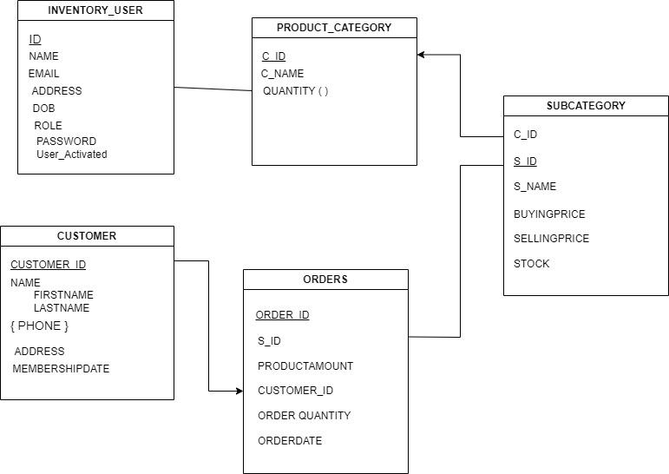

# Implementation Checklist

|  |  |
| --- | --- |
| Description | Remarks |
| Project ID | 204550 |
| Workspace Name | RAFI |
| Workspace Email | saleh.rafi.01@gmail.com |
| Workspace Password | kichuekta |
| Authentication Type | Custom |
| Username and Password to Login | Username: admin, Password: 1234  Username: testing, Password: 1234 |
|  |  |
| Number of Reports with Forms | 7 |
| Number of Reports based on Queries, Aggregate Queries | 8 |
|  |  |
| Extra features | We are using Sequence to generate an automatic user ID. Sometimes unique ID generation is impossible for us. It can be help to generate unique ID every time when create a new user. |
| Unique functionality | There are lots of unique functionality in our app. We use sequence, navigation menu, dropdown, authorization, custom authentication, nested subqueries and many things. |

# Reports with Forms

|  |  |  |
| --- | --- | --- |
| Report Page Number and Name | Form Page Number and Name | Table |
| 2- Details Customer Information | 7- Customer | Customer |
| CustomerName |
| CustomerPhone |
| 4- Non Admin Information | 7- Customer | InventoryUser |
| 12- Debit and Credit Information | 11- Product Category  33- Order | SubCategory |
| Orders |
| 14- Inventory User Details | 13- Inventory User | InventoryUser |
| 17- Category Wise Customer | 33- Order  21- Sub Category  11- Product Category | Customer |
| CustomerName |
| CustomerPhone |
| 22- Product Category Details | 11- Product Category | ProductCategory |
| 23- Random Customer | 33- Order  21- Sub Category | Customer |
| CustomerName |
| CustomerPhone |
| 26- Sub Category Details | 21- Sub Category | SubCategory |
| 28- Customer Info | 7- Customer  9- Customer Name | Customer |
| CustomerName |
| CustomerPhone |
| 30- details Customer | 7- Customer  9- Customer Name  10- Customer Phone | Customer |
| CustomerName |
| CustomerPhone |
| 31- VIP Customers | 7- Customer  9- Customer Name  10- Customer Phone  33- Order | Customer |
| CustomerName |
| CustomerPhone |
| 34- Order Details | 33- Order  7- Customer | Orders |
| 36- Customer Order Details | 7- Customer  9- Customer Name  10- Customer Phone  33- Order | Orders |
| Customer |
| CustomerName |
| CustomerPhone |
| 40- Old Customers | 33- Order  7- Customer | Customer |
| CustomerName |
| CustomerPhone |
| 42- Product View | 21- Sub Category | ProductCategory |
| SubCategory |

Table Name: 13- Inventory User

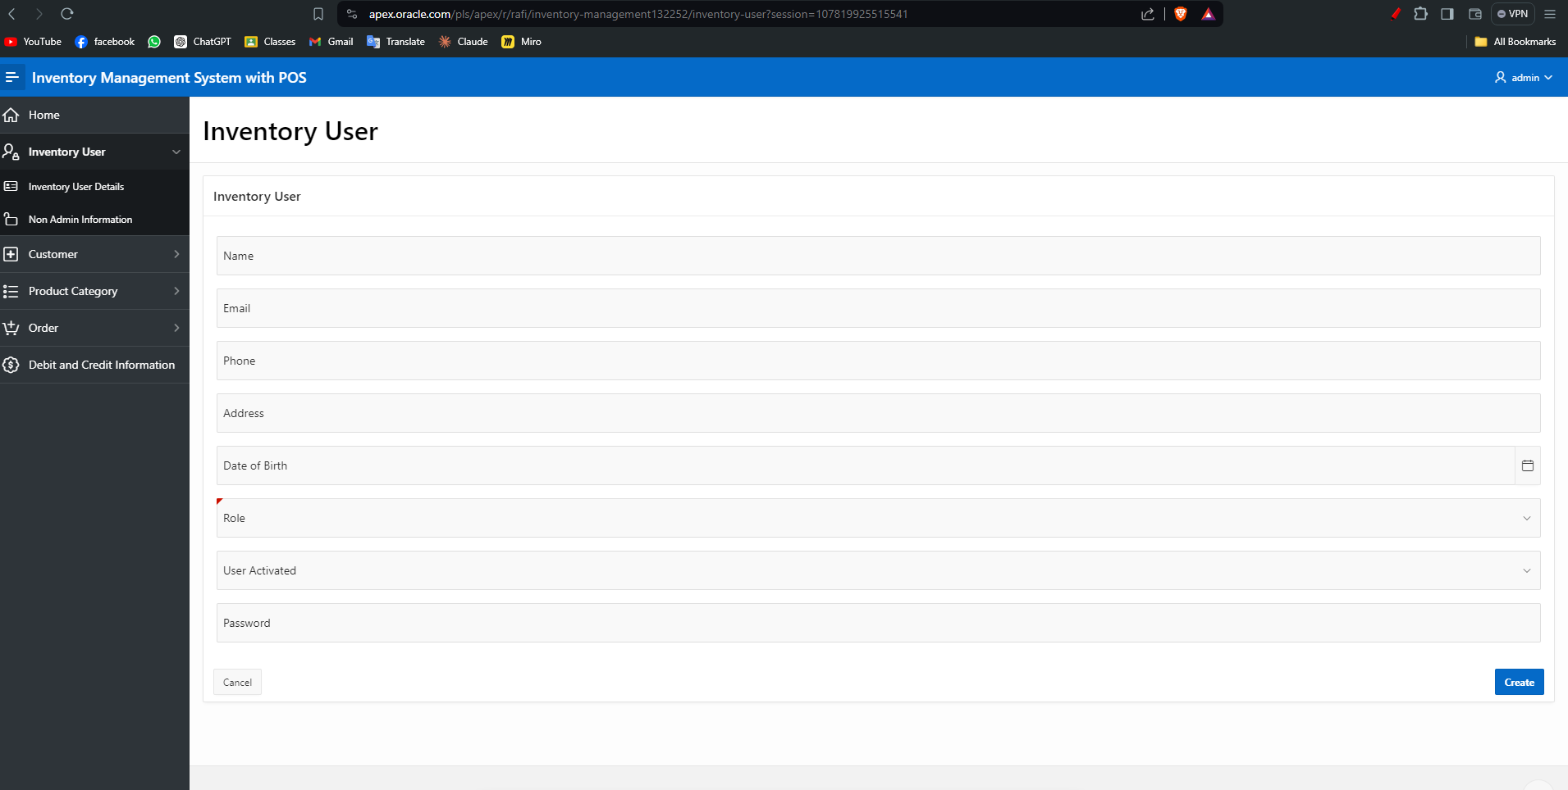

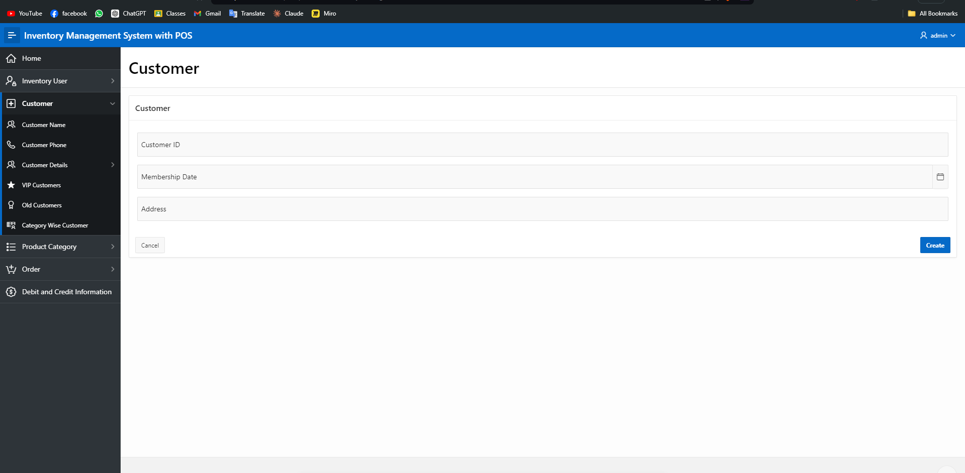

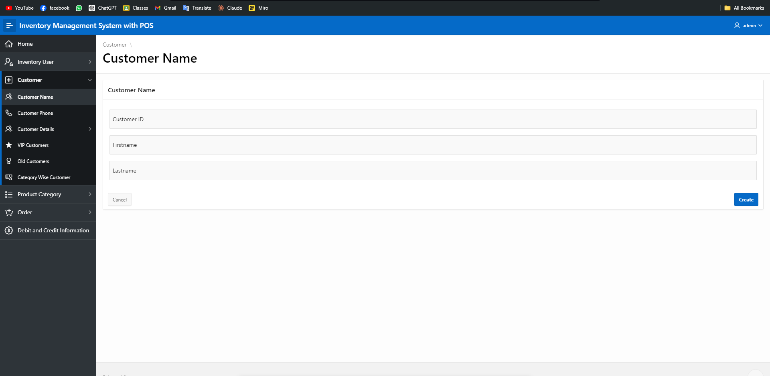

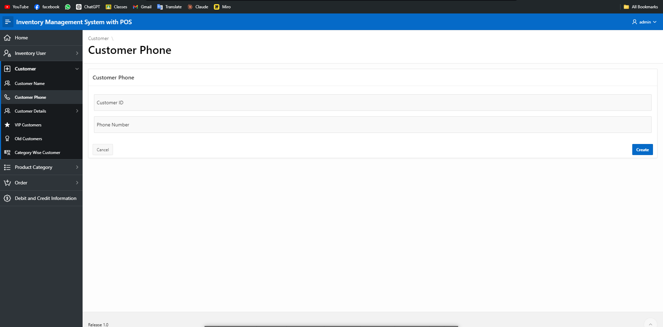

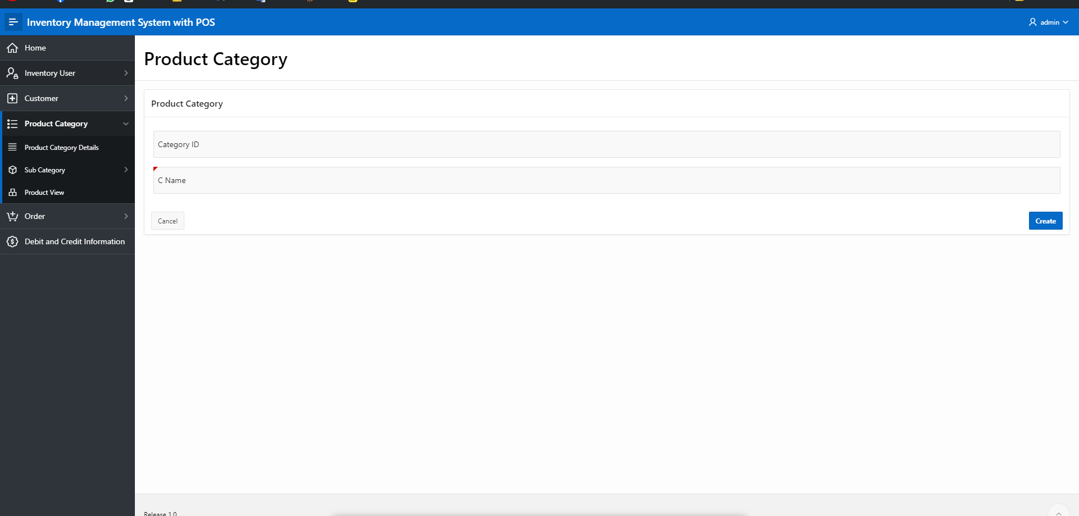

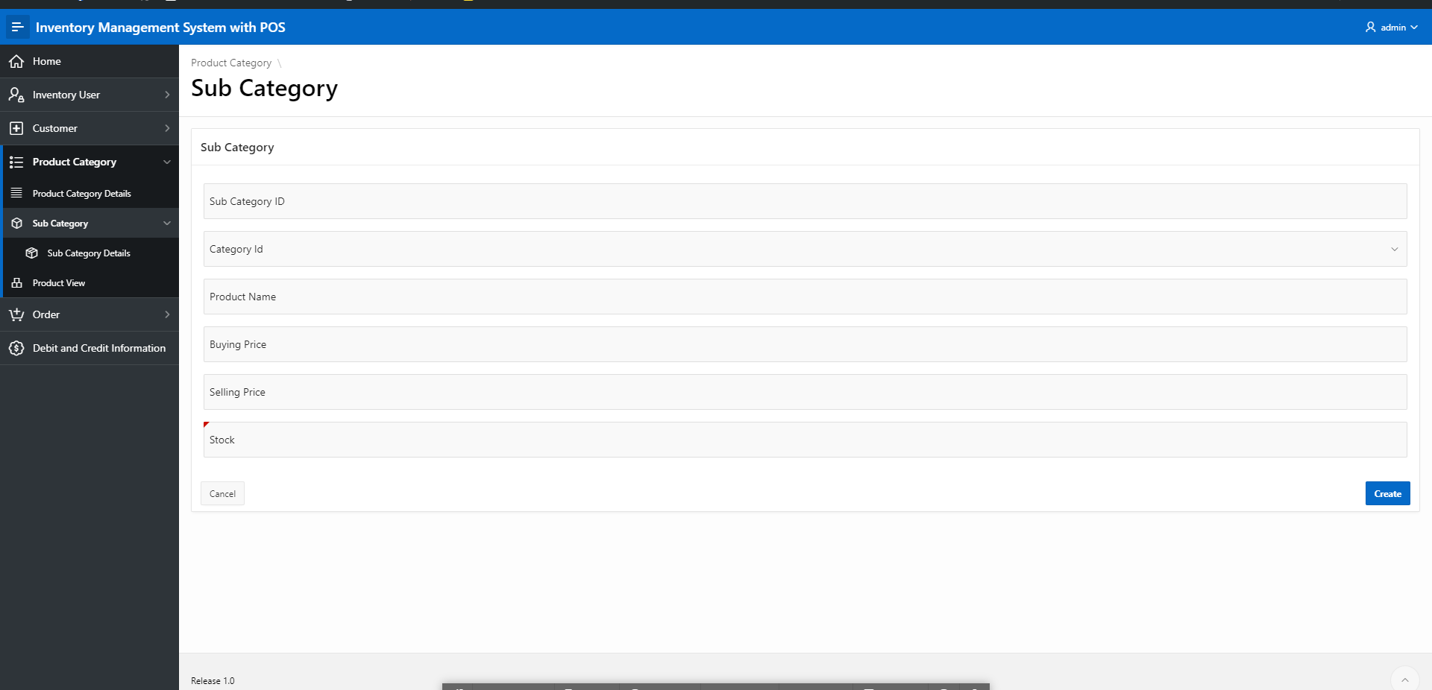

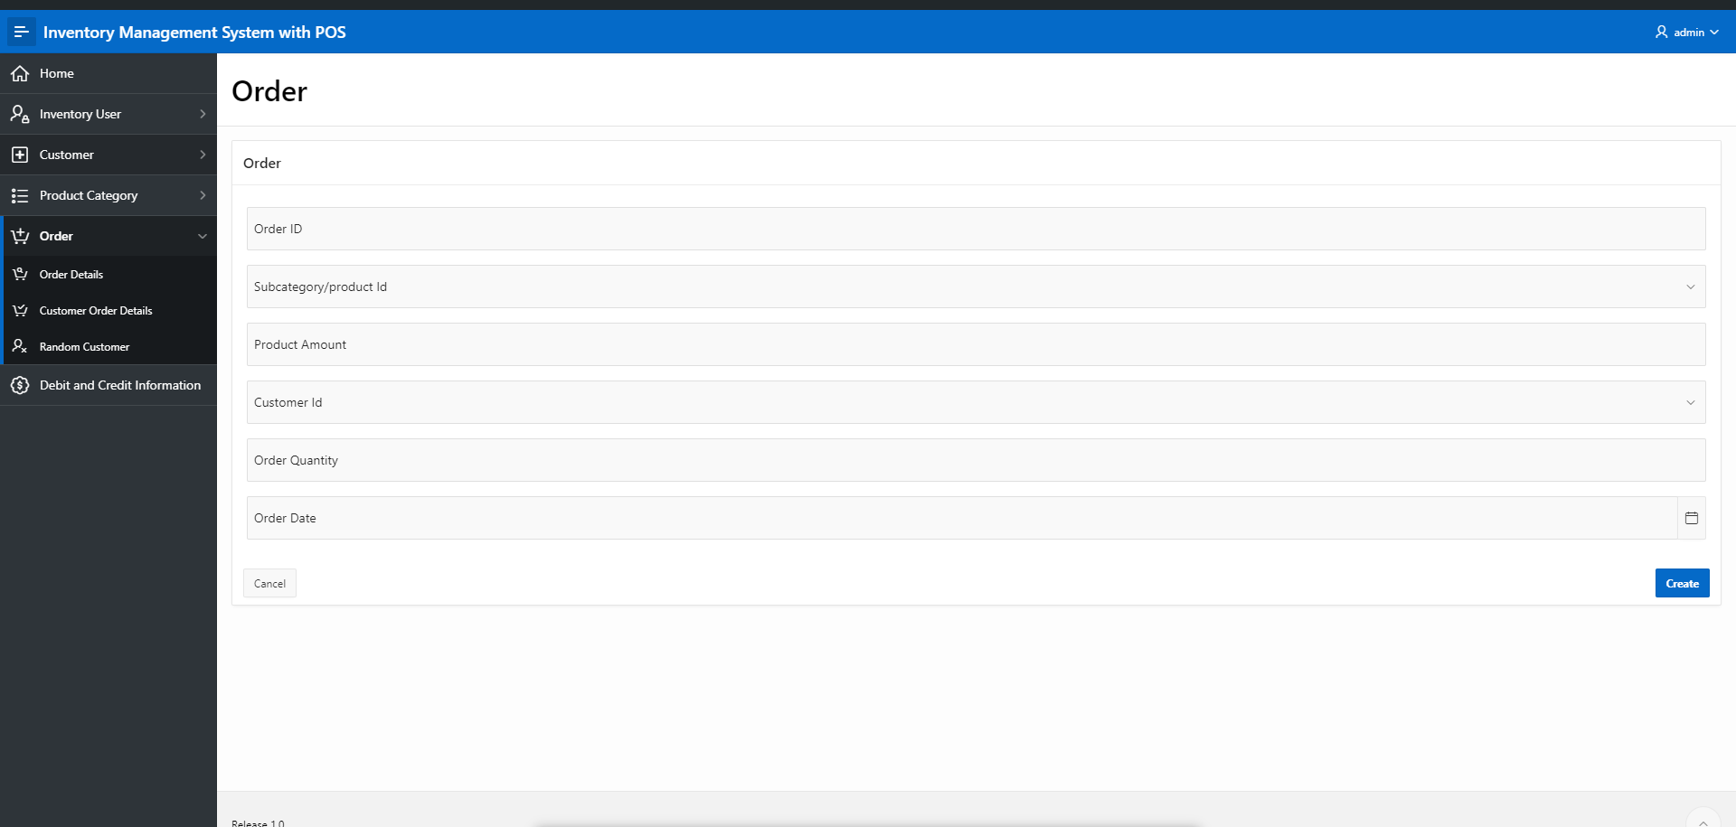

# Reports based on Multi-Table and Aggregate Queries

| Page Number and Name | Query Type | Report description |
| --- | --- | --- |
| 2- Details Customer Information | Multi-table | This table shows the details information about customer which we comes from customer, customer-Name and phone number table |
| 4- Non Admin Information | Nested Subquery | If User is not an admin then he cannot get some confidential access. This is a nested query. |
| 12- Debit and Credit Information | Multi-table and Aggregate | By analysis the order table this view is works it shows the revenue total cost and total profit. |
| 14- Inventory User Details | Normal Query | This is the simple view for showing Inventory user details |
| 17- Category Wise Customer | Multi-table | It shows the category wise customer details, for testing out default category is Grocery |
| 22- Product Category Details | Multi-table | Product category details view shows the product category and it’s id |
| 23- Random Customer | Multi-table | Non registered customer are treated as random customer |
| 26- Sub Category Details | Single-table | It shows the Product List and it’s information |
| 28- Customer Info | Multi-table | Shows full customer Information |
| 31- VIP Customers | Multi-table and Aggregate | If customer’s purchase history is grater then average customer purchase amount then the customer starred as a VIP customer |
| 34- Order Details | Multi-table | Its shows the order history of successfully created order |
| 36- Customer Order Details | Multi-table | Full order information shows in this view |
| 40- Old Customers | Multi-table | Customers who registered 1 year ago are shows in this view |
| 42- Product View | Multi-table | It shows Information about product |

Put screenshots of such types of reports. Number your figures like 6.1, 6.2 and so on.

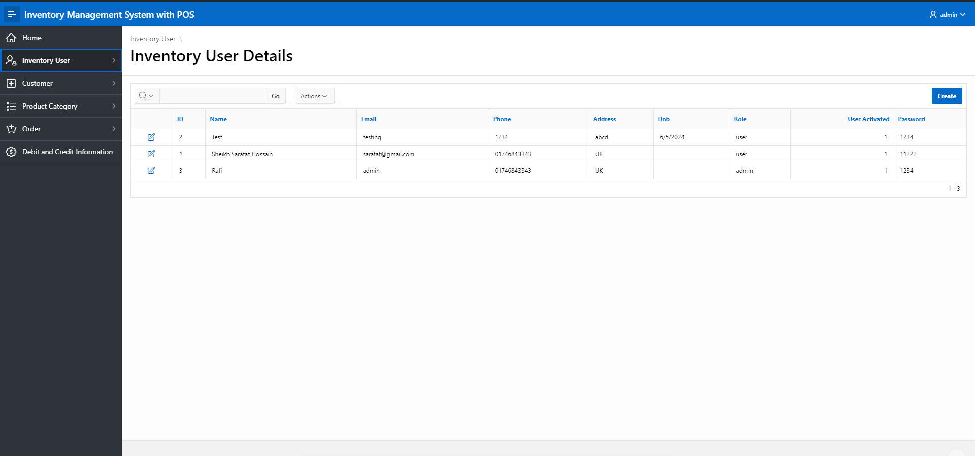

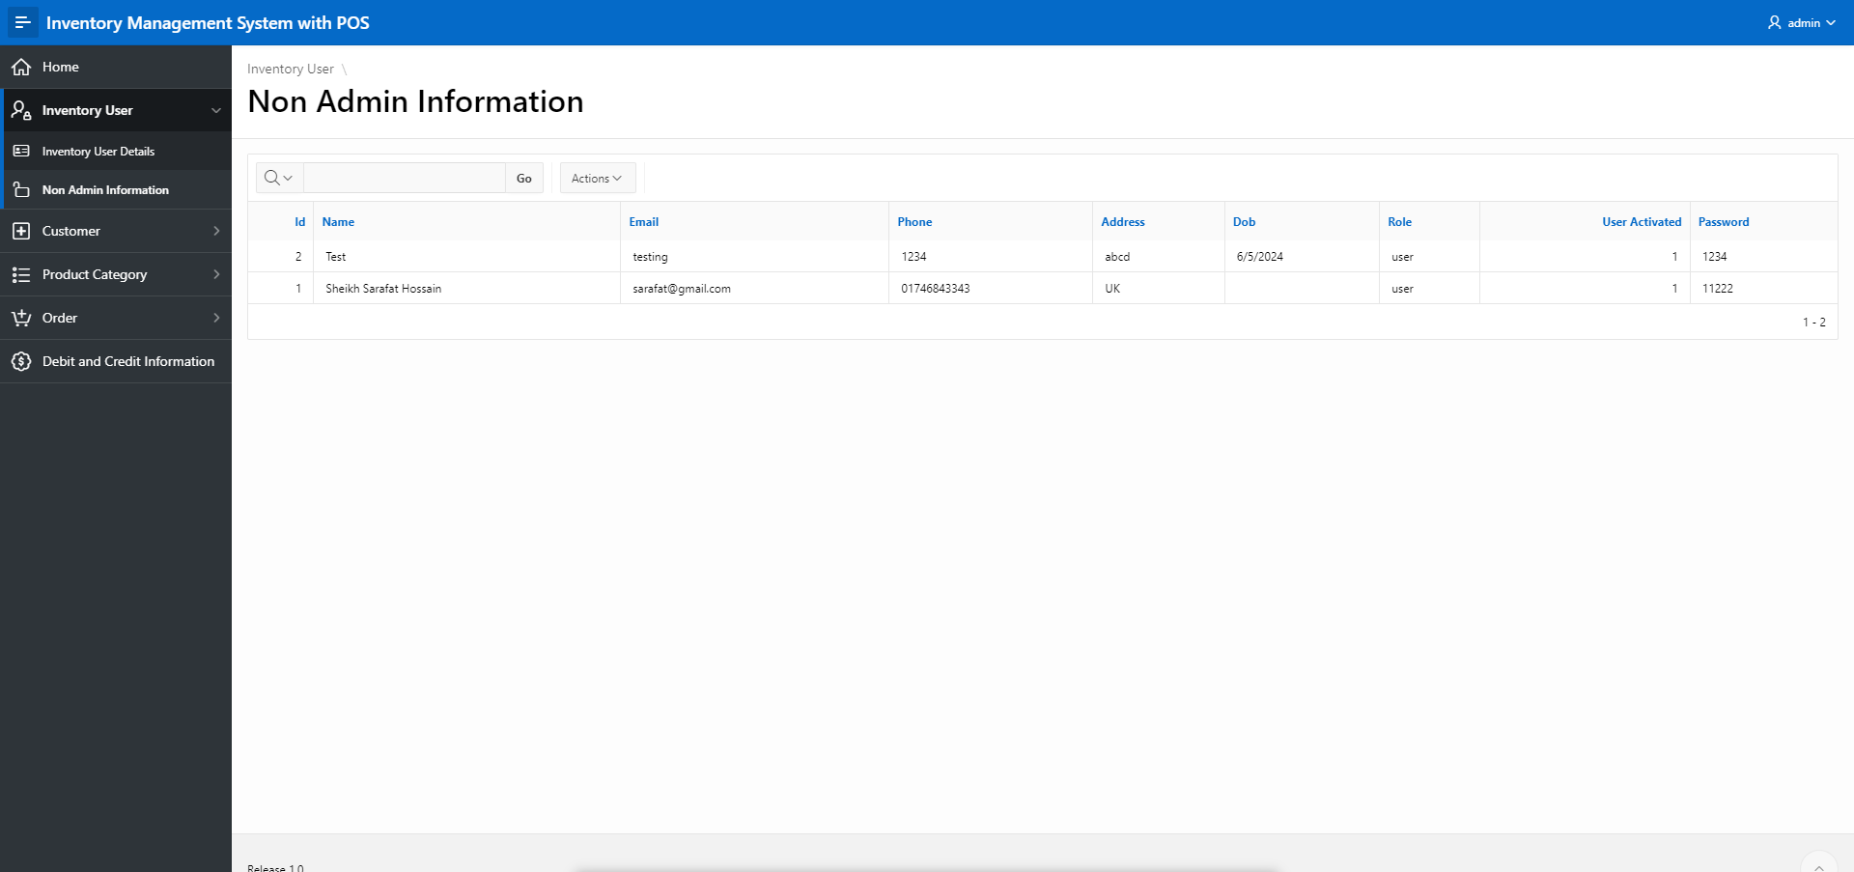

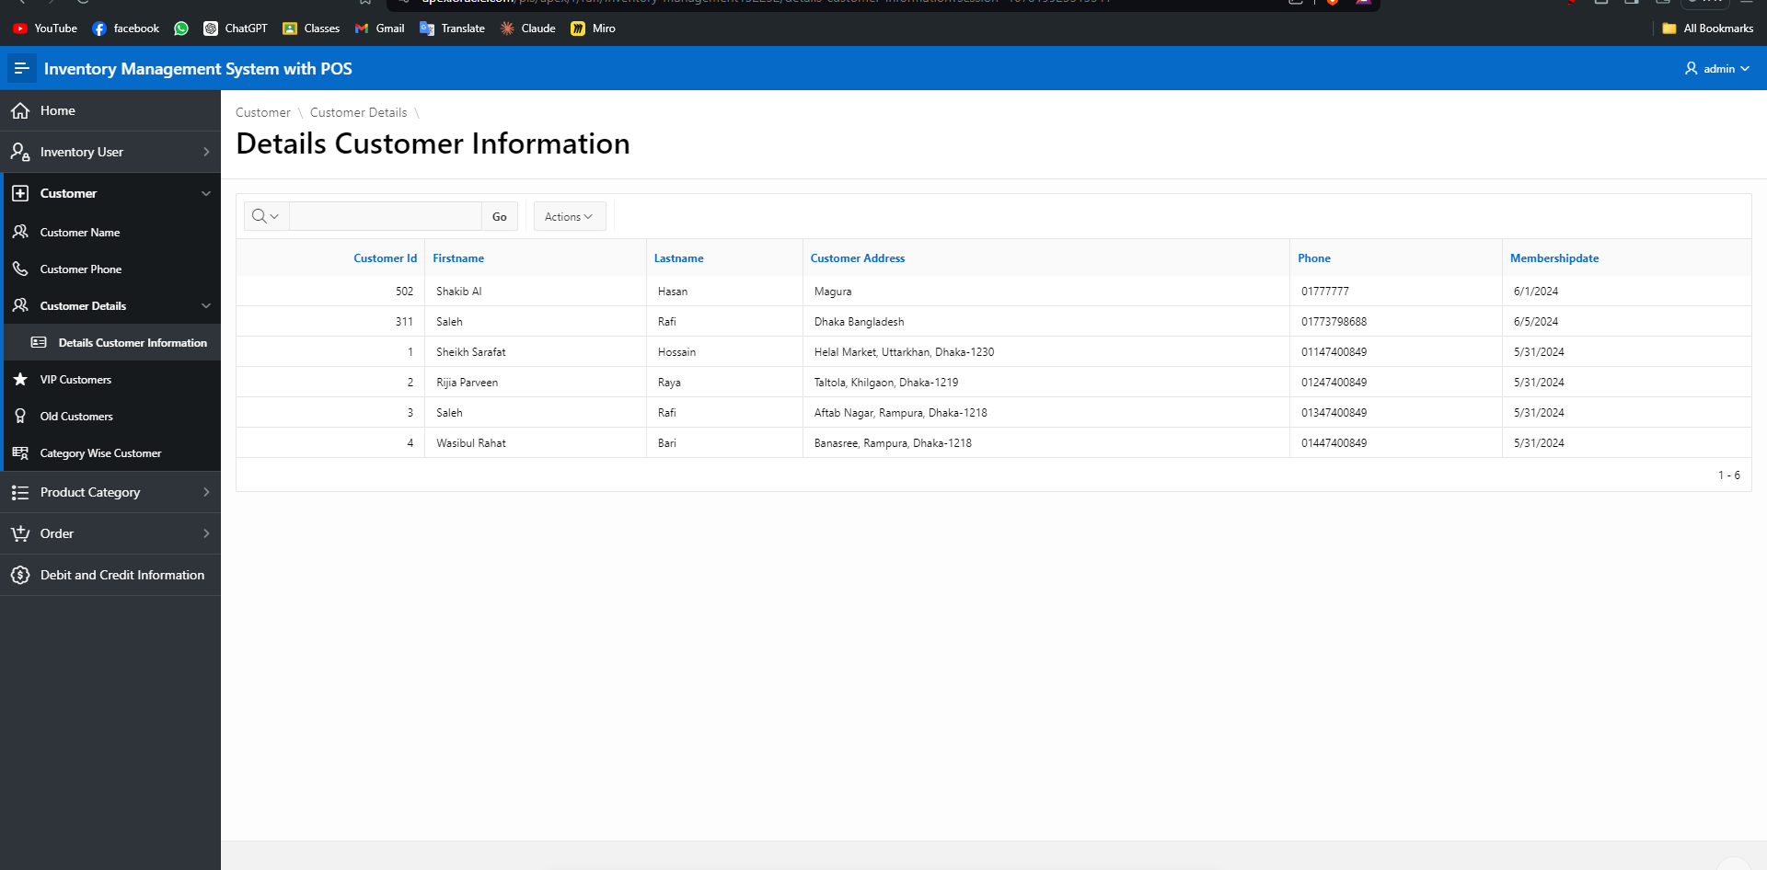

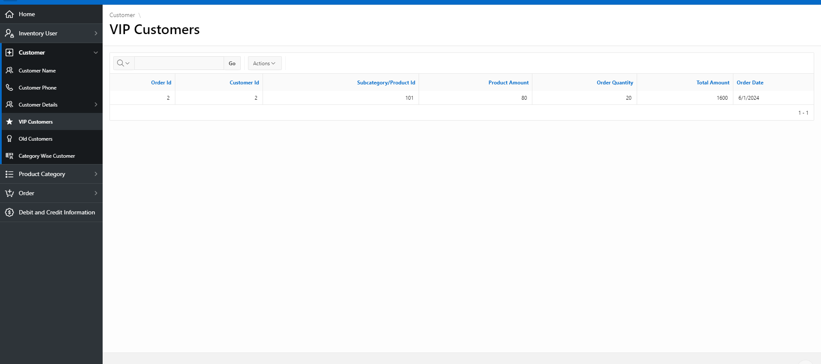

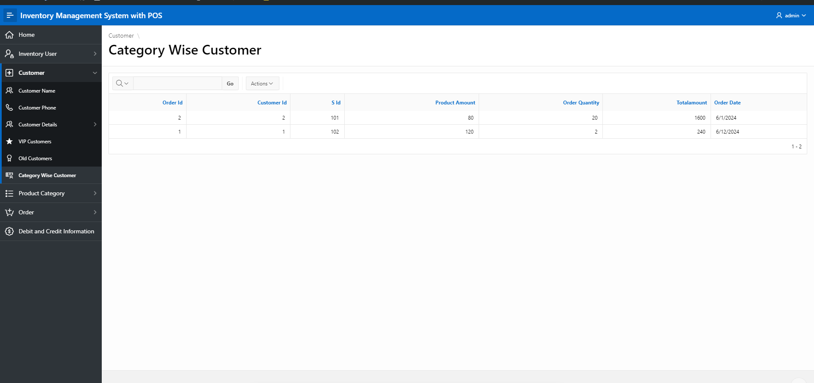

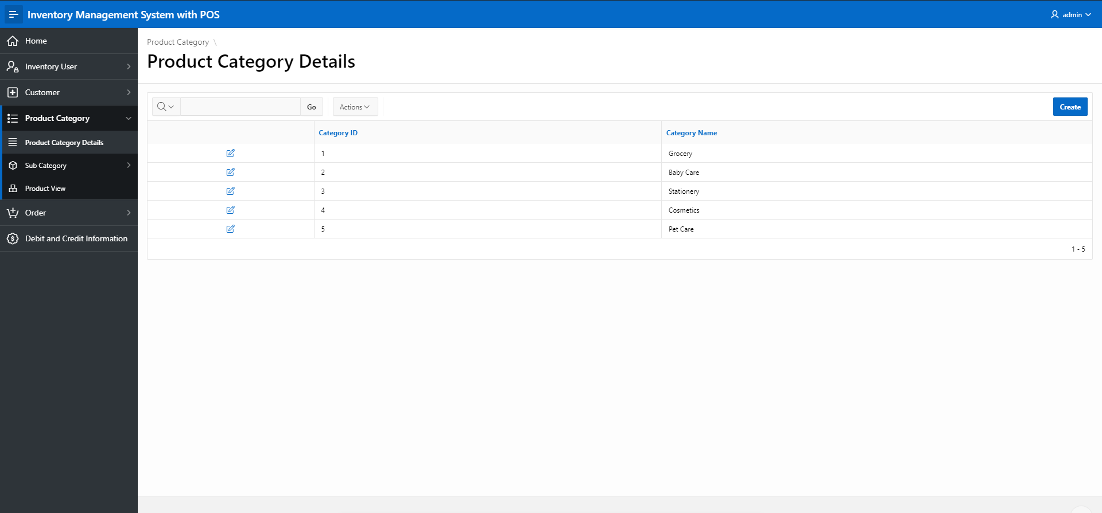

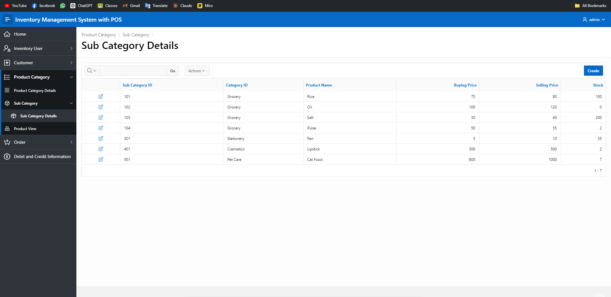

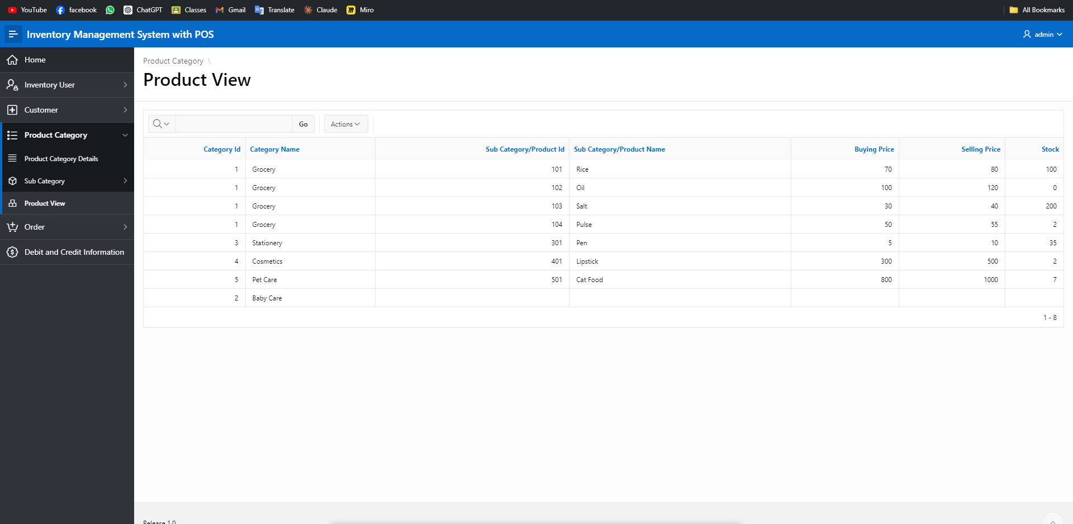

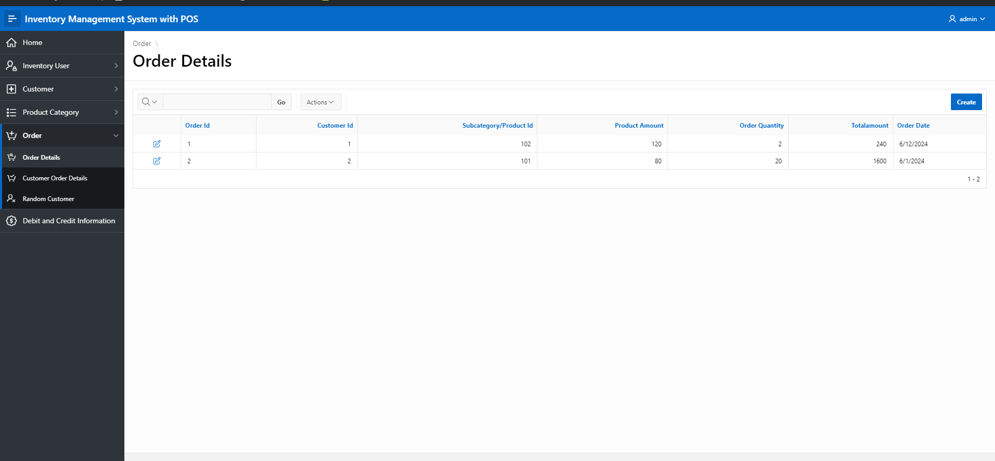

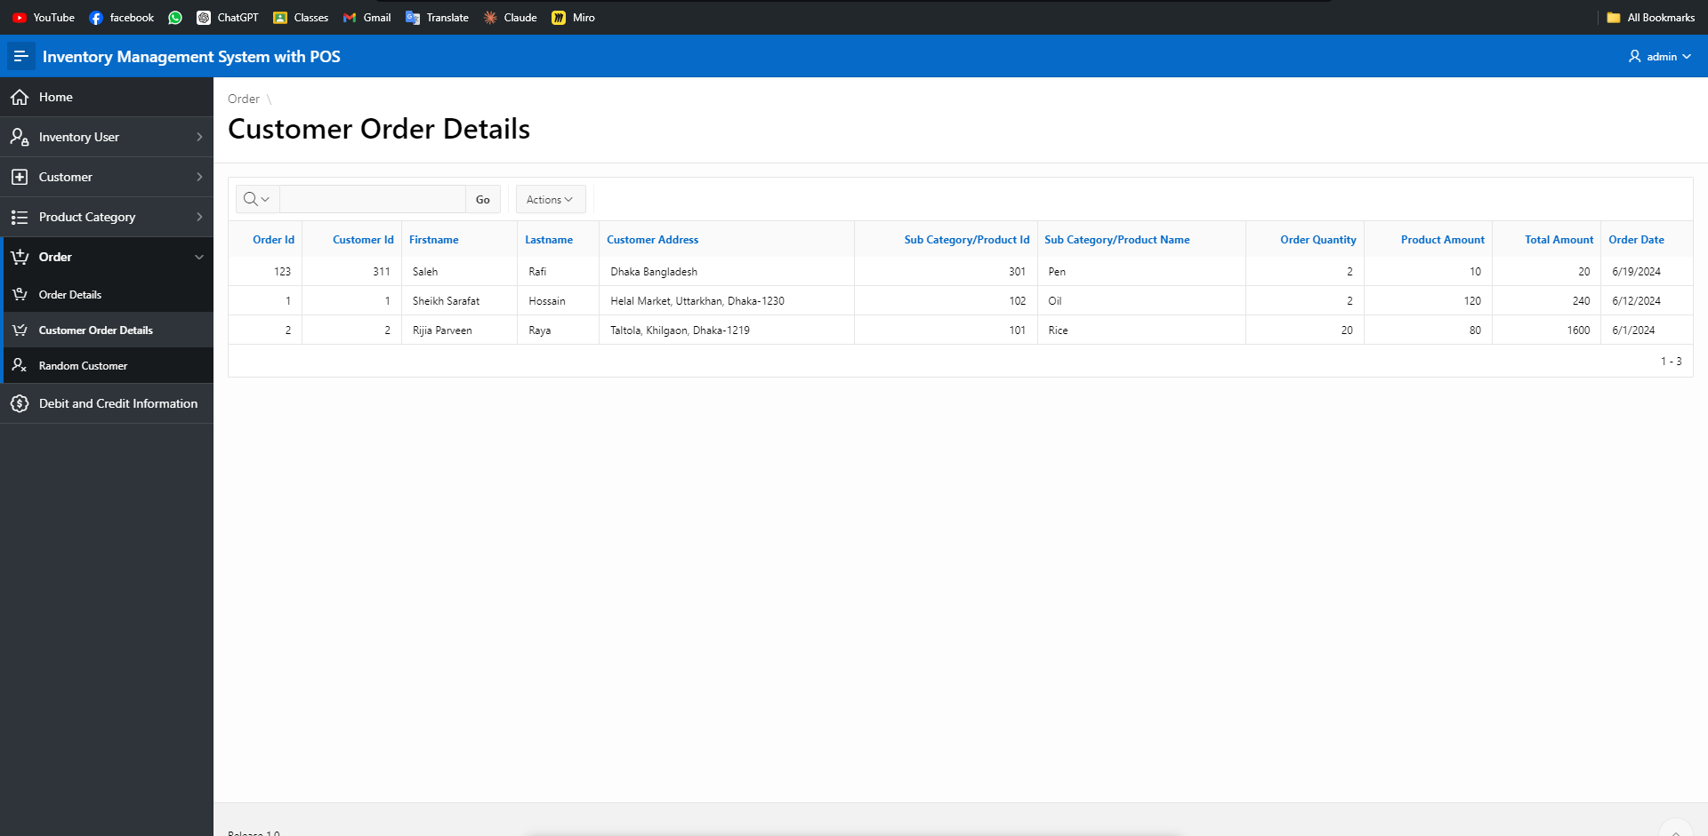

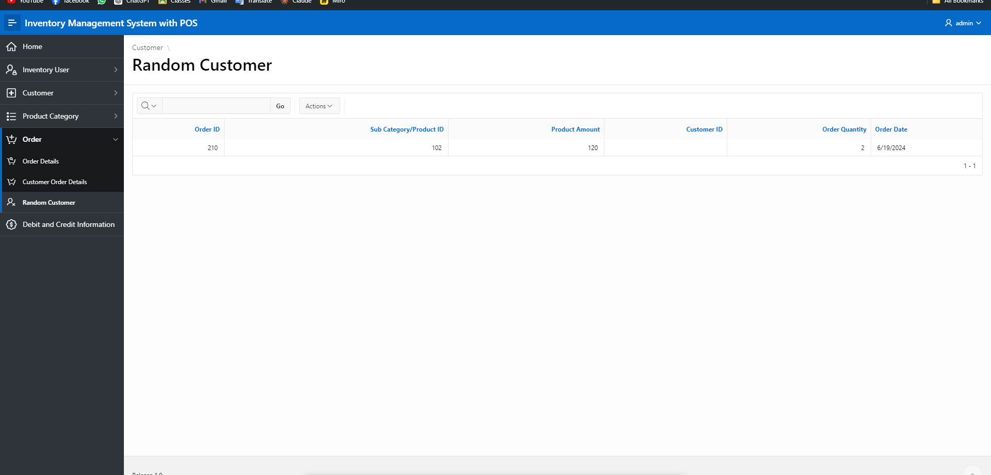

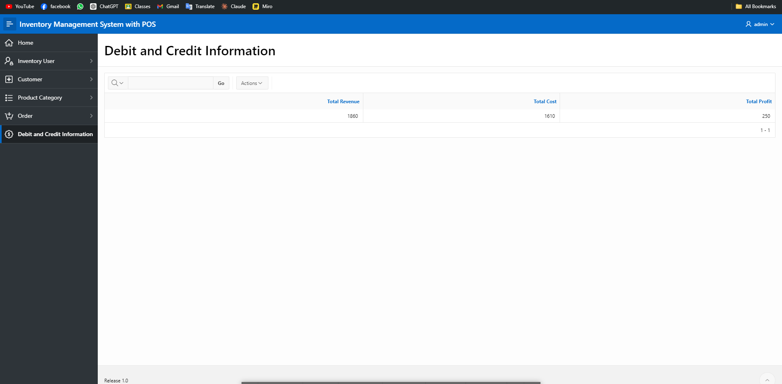

# Authorization and User Role Assignment

**User Role Assignment**

|  |  |  |
| --- | --- | --- |
| User name | Password | Role |
| admin | 1234 | Admin |
| testing | 1234 | User |
| sarafat@gmail.com | 11222 | User |
| rafi | 1111 | Admin |

# Concluding Remarks

Write briefly about your experience during the project development. Write your raw feelings without any fear. I want to hear it! Thank you and Good Luck.